PYTHON EXCERCISE

1
# Accept user input
name = input("Enter your name: ")
# Convert age to integer to demonstrate a different data type
age = int(input("Enter your age: "))

# Print a formatted message
print(f"\nHello {name}! You are {age} years old.")

# Display the data type of each variable
print(f"Data type of 'name': {type(name)}")
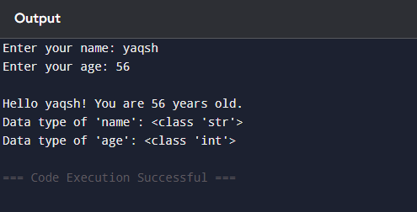
2
# Get input from the user
num = float(input("Enter a number: "))

# Determine if the number is positive, negative, or zero
if num > 0:
print("The number is positive.")
elif num < 0:
print("The number is negative.")
else:
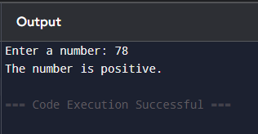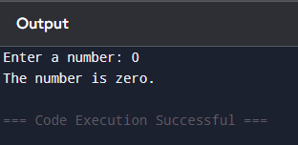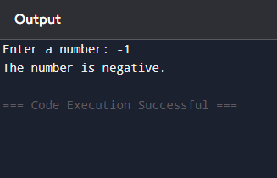 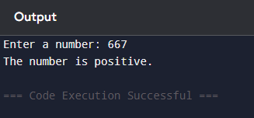 print("The number is zero.")
3
\n = int(input("Enter a positive integer: "))

total_sum = 0

# Use a for loop to iterate from 1 to n (inclusive)
for i in range(1, n + 1):
total_sum += i

print(f"The sum of the first {n} natural numbers is: {total_sum}")
# Program using a while loop
n = int(input("Enter a positive integer: "))

total_sum = 0
current_number = 1

while current_number <= n:
total_sum += current_number
current_number += 1

print(f"The sum is: {total_sum}")

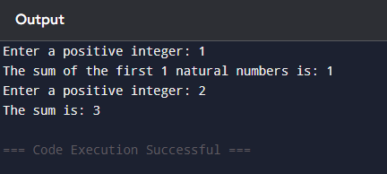
4
A simple program to demonstrate operators in Python

# 1. Arithmetic Operators (Used for calculations)
x = 10
y = 3
print(f"Arithmetic: {x} + {y} = {x + y}") # Addition
print(f"Arithmetic: {x} % {y} = {x % y}") # Modulo (Remainder)
print(f"Arithmetic: {x} ** {y} = {x ** y}") # Exponentiation (10^3)

# 2. Comparison Operators (Result in True or False)
a = 15
b = 20
print(f"Comparison: Is {a} > {b}? {a > b}") # Greater than
print(f"Comparison: Is {a} != {b}? {a != b}") # Not equal to

# 3. Logical Operators (Used to combine conditional statements)
age = 25
has_license = True

# Returns True if both conditions are met
can_drive = age >= 18 and has_license
print(f"Logical (AND): Can drive? {can_drive}")

# Returns True if at least one condition is met
is_weekend = False
is_holiday = True
stay_home = is_weekend or is_holiday
print(f"Logical (OR): Stay home? {stay_home}")

# Reverses the result
print(f"Logical (NOT): Opposite of True is {not True}")

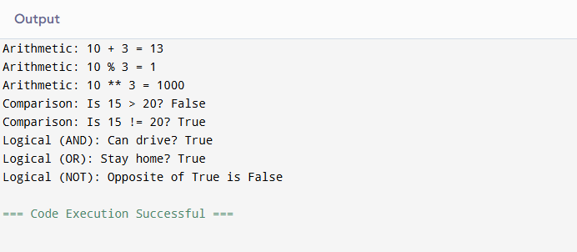
5
def process_numbers():
try:
# 1. Read input from the user and split into a list of strings
user_input = input("Enter numbers separated by spaces: ")

# 2. Convert strings to numbers (floats) using a list comprehension
numbers = [float(x) for x in user_input.split()]

# Check if the list is empty to avoid errors
if not numbers:
print("The list is empty. Please enter some numbers.")
return

# 3. Find maximum, minimum, and sum using built-in functions
maximum = max(numbers)
minimum = min(numbers)
total_sum = sum(numbers)

# 4. Sort the list in ascending order
numbers.sort()

# 5. Display the results
print(f"\n--- Results ---")
print(f"Maximum: {maximum}")
print(f"Minimum: {minimum}")
print(f"Sum: {total_sum}")
print(f"Sorted List: {numbers}")

except ValueError:
print("Invalid input! Please enter only numeric values.")

# Run the function
process_numbers()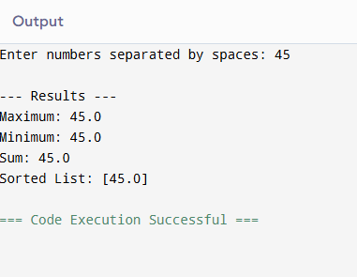
7
def get_factorial(n):
"""Calculates factorial of a number using recursion."""
if n < 0:
return "Factorial is not defined for negative numbers"
if n == 0 or n == 1:
return 1
return n * get_factorial(n - 1)

def get_fibonacci_sequence(terms):
"""Generates Fibonacci sequence up to 'terms' using an iterative approach."""
if terms <= 0:
return []
elif terms == 1:
return [0]

sequence = [0, 1]
while len(sequence) < terms:
# Each subsequent number is the sum of the previous two
sequence.append(sequence[-1] + sequence[-2])
return sequence

# Example usage:
number = 5
print(f"Factorial of {number}: {get_factorial(number)}")
print(f"Fibonacci sequence ({number} terms): {get_fi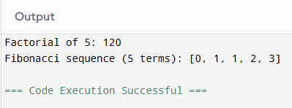bonacci_sequence(number)}")
8
# Dictionary storing student names and their marks
student_scores = {
"Alice": 85,
"Bob": 92,
"Charlie": 78,
"David": 95,
"Emma": 88
}

# Finding the student with the highest score
# We use student_scores.get to look up the marks based on the name
top_student = max(student_scores, key=student_scores.get)
highest_score = student_scores[top_student]

# Finding the student with the lowest score
bottom_student = min(student_scores, key=student_scores.get)
lowest_score = student_scores[bottom_student]

# Displaying the results
print("Student Scores:", student_scores)
print(f"Highest Score: {highest_score} (scored by {top_student})")
print(f"Lowest Score: {lowest_score} (scored by {bottom_student})")

